Module 3

1) What is RDBMS?

Ans.

* The software used to store, manage, query, and retrieve data stored in a relational database is called

a relational database management system (RDBMS). The RDBMS provides an interface between users

and applications and the database, as well as administrative functions for managing data storage, access,

and performance.

2) What is SQL?

Ans.

* SQL is Structured Query Language, which is a computer language for storing, manipulating and retrieving data stored in relational database.
* SQL is the standard language for Relation Database System. All relational database management systems like MySQL, MS Access, Oracle, Sybase, Informix, postgres and SQL Server use SQL as standard database language.
* Also, they are using different dialects, such as:
* MS SQL Server using T-SQL, ANSI SQL.
* Oracle using PL/SQL.
* MS Access version of SQL is called JET SQL (native format) etc.

3) write SQL commands?

Ans.

* DDL – Data Definition Language
* DML – Data Manipulation Language
* DCL – Data Control Language
* DQL – Data Query Language

4) write type of joins.?

Ans.

* INNER JOIN: returns rows when there is a match in both tables.
* LEFT JOIN: returns all rows from the left table, even if there are no matches in the right table.
* RIGHT JOIN: returns all rows from the right table, even if there are no matches in the left table.
* FULL JOIN: returns rows when there is a match in one of the tables.

5) what is join.?

Ans.

* A join clause in the Structured Query Language (SQL) combines columns from one or more tables into a new table.

The operation corresponds to a join operation in relational algebra.

6) How Many constraint and describes it self?

Ans.

* Constraints can be categorized into five types: A NOT NULL constraint is a rule that prevents null values from being entered into one or more columns within a table.

A unique constraint (also referred to as a unique key constraint) is a rule that forbids duplicate values in one or more columns within a table

7) Difference between RDBMS vs DBMS?

Ans.

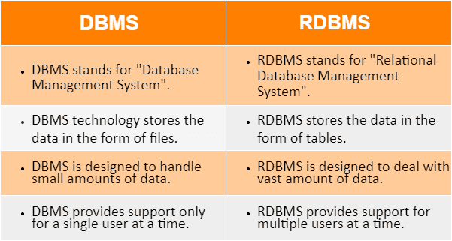

8) What is API Testing?

Ans.

* API testing is a type of software testing that involves testing application programming interfaces directly and as part of integration testing to determine

if they meet expectations for functionality, reliability, performance, and security. Since APIs lack a GUI, API testing is performed at the message layer.

9) Types of API Testing?

Ans.

* Open APIs: These types of APIs are publicly available to use like OAuth APIs from Google. It has also not given any restriction to use them. So, they are also known as Public APIs.
* Partner APIs: Specific rights or licenses to access this type of API because they are not available to the public.
* Internal APIs: Internal or private. These APIs are developed by companies to use in their internal systems. It helps you to enhance the productivity of your teams

10) What is Responsive Testing?

Ans.

* A responsive web design involves creating a flexible web page that is accessible from any device, starting from a mobile phone to a tablet.
* Furthermore, a responsive web design improves users’ browsing experience.
* Considering this from a quality assurance perspective, a responsive web design requires thorough evaluation using a variety of devices before it is ready to go live.
* Software testers may find it challenging to perform responsive design testing as a variety of factors are to be looked into during the testing phase.
* Some points to be understand for Responsive Testing.

* The challenges involved in testing a responsive website
* How website testing differs from a mobile device to a computer
* Rules and guidelines to be followed during responsive design testing and
* Lastly, various tools available to perform responsive testing

11) Which types of tools are available for Responsive Testing?

Ans.

* LT Browser
* Lembda Testing
* Google Resizer
* I am responsive
* Pixel tuner

12) What is the full form of .ipa, .apk?

Ans.

* APK stands for Android Application Package.
* Intelligent Process Automation

13) How to create step for to open the developer option mode ON?

Ans.

* Enable Developer options

Tap the Build Number option seven times until you see the message You are now a developer!

This enables developer options on your device. Return to the previous screen to find Developer options at the bottom.